**MongoDB Day 1**

1. Find all the information about each products

**Solution:** db.products.find({})

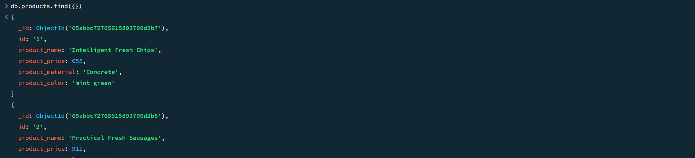

2. Find the product price which are between 400 to 800

**Solution:** db.product.find({“product_price”:{$gte:400,$lte:800}})

3.Find the product price which are not between 400 to 600

**Solution:** db.products.find({“product_price”:{$not:{$gte:400,$lte:600}}})

4. List the four product which are grater than 500 in price

**Solution:** db.products.find({ "product_price": { $gt: 500 } }).limit(5)

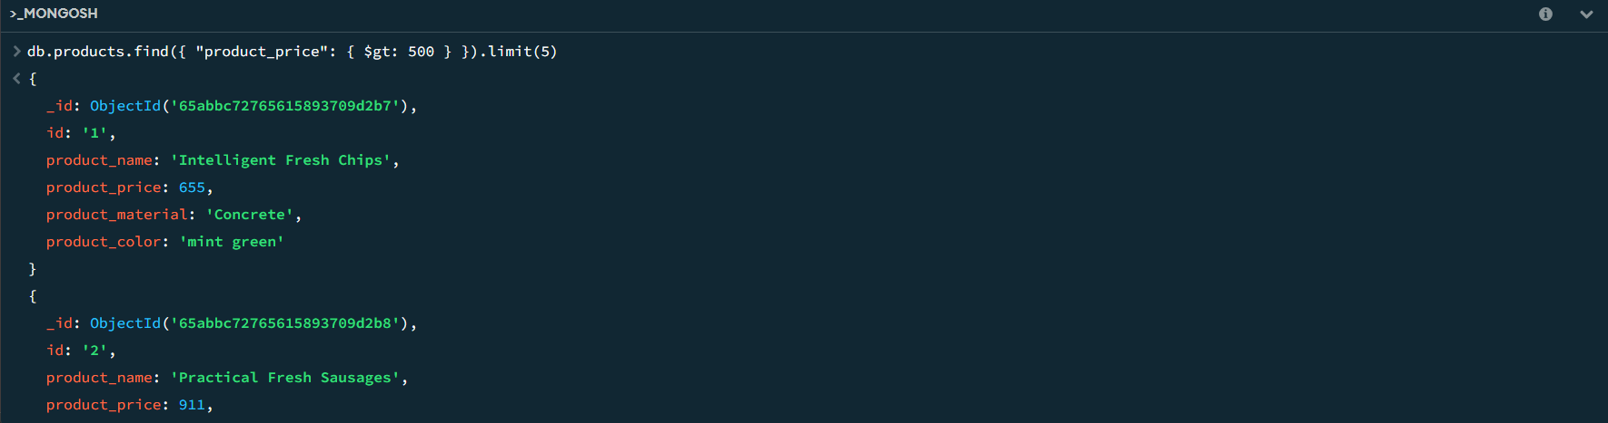

5. Find the product name and product material of each products

**Solution:** db.products.find({}, { "product_name": 1, "product_material": 1, "_id": 0 })

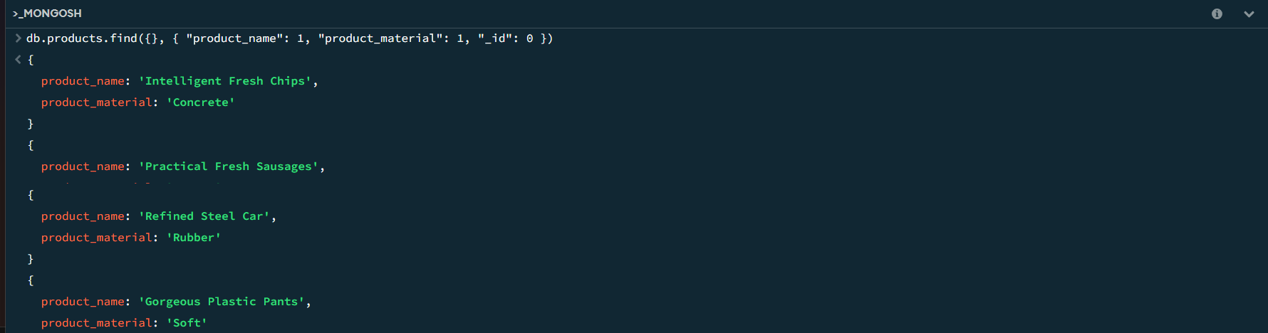

6. Find the product with a row id of 10

**Solution:** db.products.findOne({ "id": "10" })

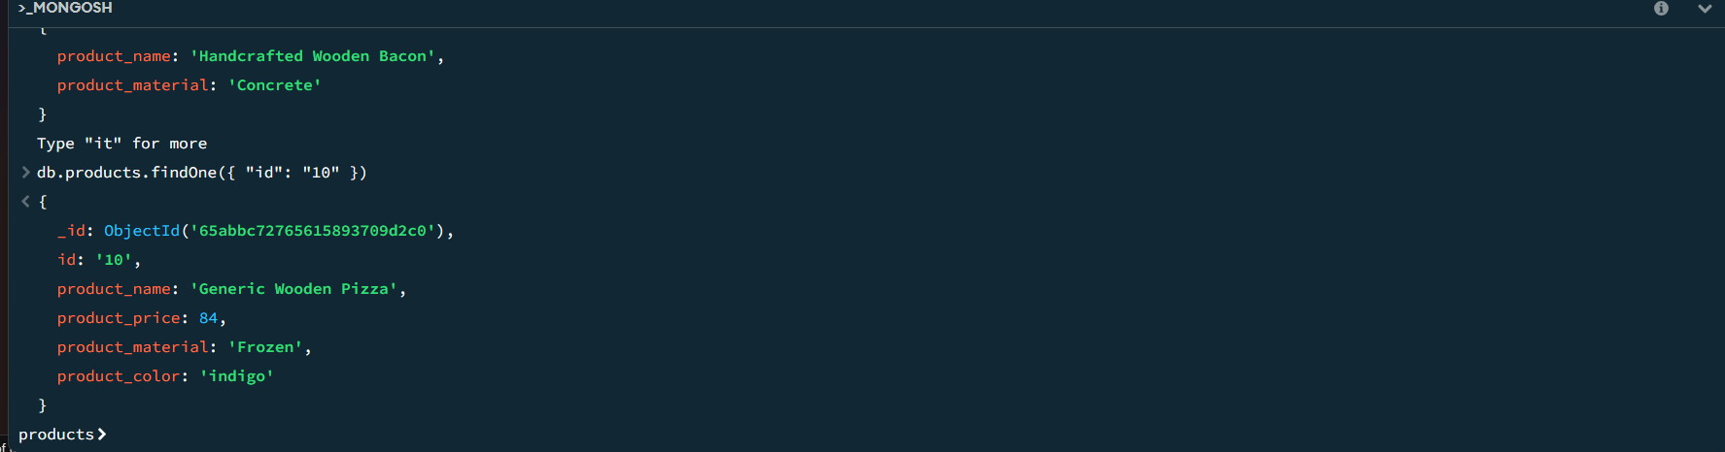

7. Find only the product name and product material

**Solution:** db.products.find({}, { "product_name": 1, "product_material": 1, "_id": 0 })

8. Find all products which contain the value of soft in product material

**Solution:** db.products.find({ "product_material": { $regex: /soft/i } })

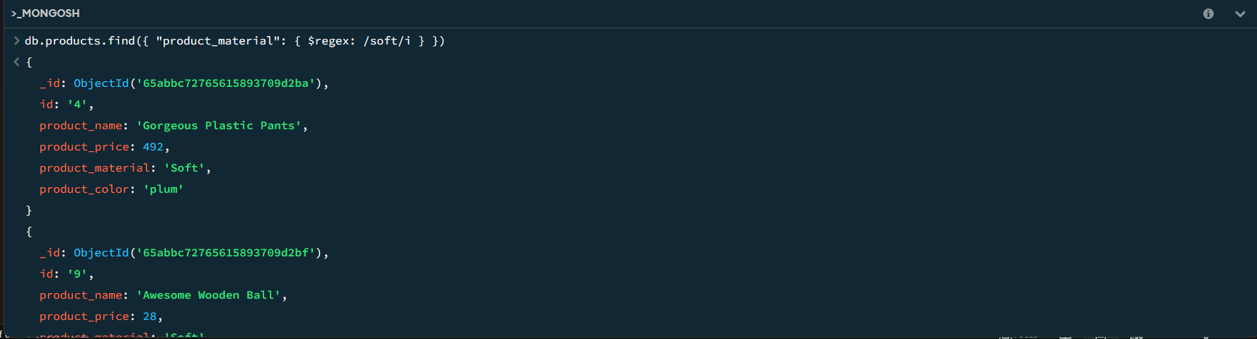

9. Find products which contain product color indigo  and product price 492.00

**Solution:** db.products.find({ "product_color": "indigo", "product_price": 492.00 })

10. Delete the products which product price value are same

**Solution:** db.products.deleteMany({ "product_price": { $eq: 492.00 } })

